Mouhammadou Dabo

April 15, 2021

CS 1675: Intro to Machine Learning

Professor Milos Hauskrecht

Problem Assignment 11 – Part 1

**Problem 1.** Reinforcement learning agent

**Part a.** N/A

**Part b.**

|  |  |  |  |
| --- | --- | --- | --- |
| **Step #** | **State** | **Action** | **Reward** |
| **1** | 1 | 1 | 2 |
| **2** | 2 | 1 | 1 |
| **3** | 3 | 3 | 0 |
| **4** | 1 | 1 | 2 |
| **5** | 2 | 1 | 2 |
| **6** | 2 | 1 | 2 |
| **7** | 2 | 1 | 1 |
| **8** | 3 | 3 | 2 |
| **9** | 4 | 2 | 3 |
| **10** | 1 | 1 | 2 |

**Table 1:** State-Action-Reward Trajectory for Policy (1, 1, 3, 2)T

**Part c.**

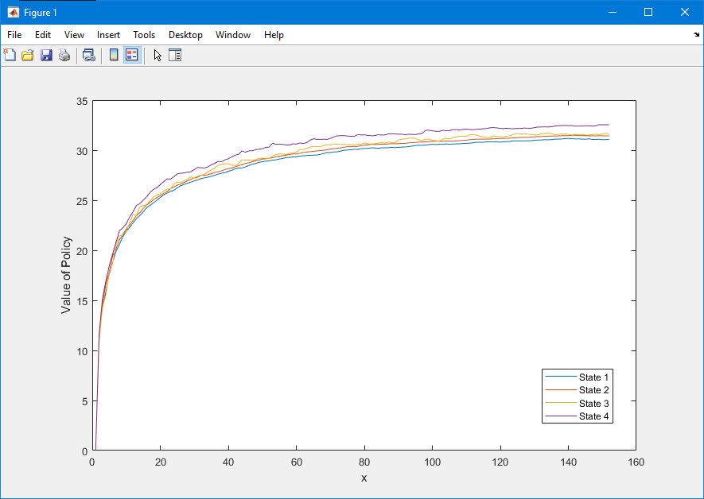

**Graph 1:** Changes in Vπ for Policy (1, 1, 3, 2)T

By inspecting the graph the estimates do converge; the four states slowly converge between the values 30 and 35 as the number of steps increase to 15,000.

**Part d.**

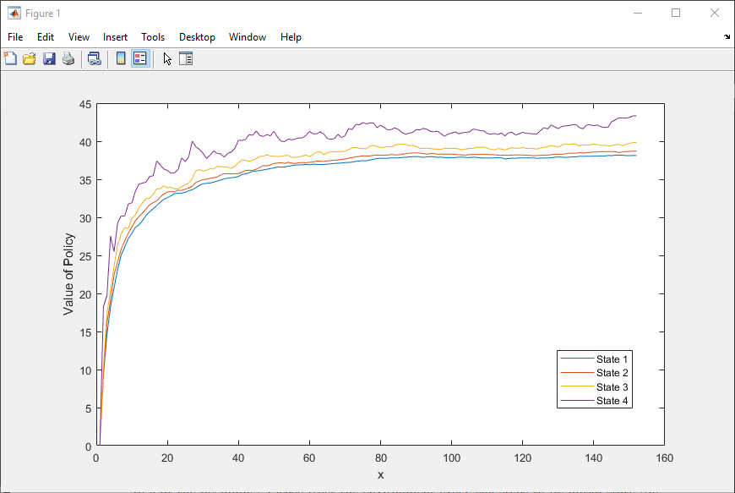

**Graph 2:** Changes in Vπ for Policy (1, 2, 3, 1)T

By implementing a new policy of (1, 2, 3, 1)T, the results of this policy are worse than the results of the policy (1, 1, 3, 2)T. The states in this new policy spike more than in the other policy; the other graph is smoother than this one.

**Part e.**

The learned policy using the Q-learning algorithm was better than the policies I tried in Part c and d. The resulting policy was (3, 1, 3, 1).

**Problem 2. Eigenfaces**

**Task 1.**

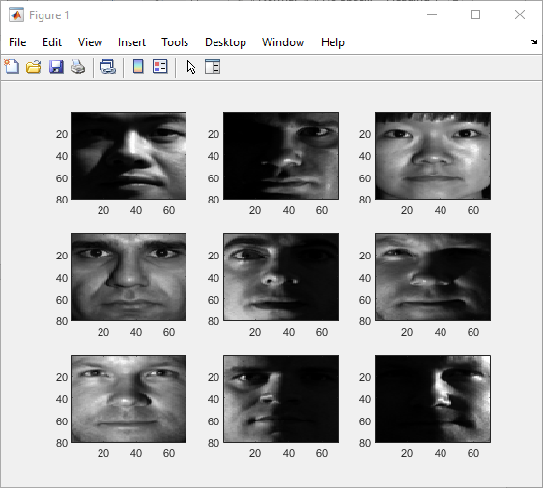

**Image 1:** Original

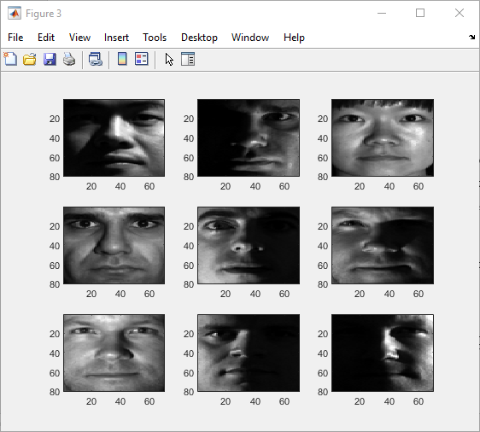

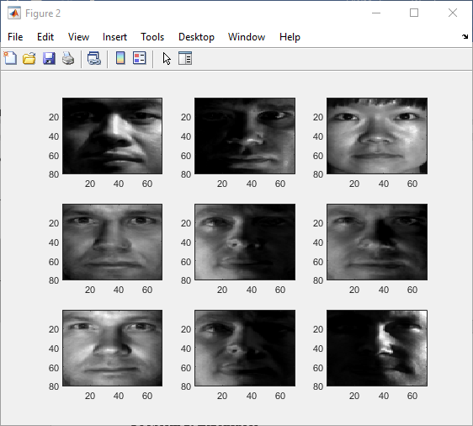

**Image 2:** m = 5 **Image 3:** m = 20

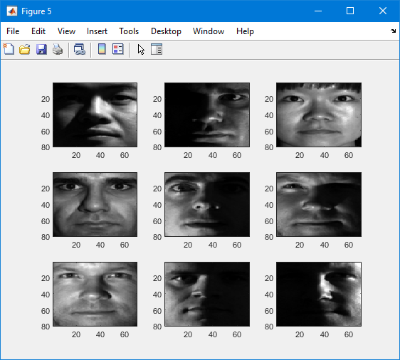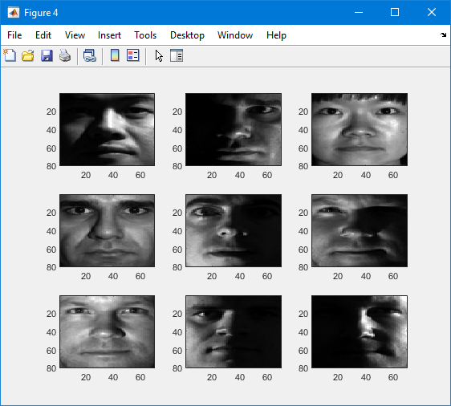

**Image 4:** m = 50 **Image** **5**: m = 100

Comparing the original and reconstructed images, the reconstructed images are very good. The images from PCA start to become good approximations of the original images when m is greater than 5. When m = 5, the image is either darker or blurry, but when m > 5, the images look identical to the original.

**Task 3.**

K-nearest neighbor classification is a method for classifying objects based on the closest training examples in the feature space. The training process consist of storing feature vectors and labels of the training images. In the classification process, the unlabeled query point is assigned as the k nearest neighbors by majority vote.

If k=1, the object is classified as the class of the object nearest to it. When there are only two classes, k must be an odd integer. After each image is converted to a vector of fixed-length with real numbers, we use Euclidean distance:

$$d\left(x,y\right)=\left\|x-y\right\|=\sqrt{\left(x-y\right)*\left(x-y\right)}$$

$$=(\sum_{i=1}^{m}{{({\left(x_{i}-y_{i}\right)}^{2}))}^{1/2}}$$

Where x and y are histograms in *X = Rm*